Sampler Stories Huswif Class Registration

Sampler Stories Huswif Class (Virtual Program)
Cissy Smith of Gentle Pursuit Designs

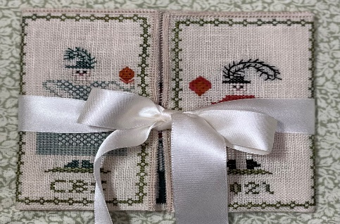

The kit includes linen count of your choice, floss, chart, and ribbon. Finished size approximately 8” X 4”.

Saturday October 05, 2024, at 10:00 PDT Time.
Kit/Class/US Shipping $140 for Members $170 for Non-Members
(Shipping outside the US will be extra. Please contact Sue Lambert)
Deadline to sign up/payment June 30th NO LATE REGISTRATIONS WILL BE ACCEPTED

Registration: ** KITS WILL BE MAILED DIRECTLY TO YOU**

Name:______________________________________________________________________

Phone: _____________________________email:____________________________________

Mailing Address: ____________________________________________________________

____________________________________________________________________________

Linen Count: 32ct________ 35/36ct________ 40ct________

Non-Refundable $75.00 Deposit_________ Payment in Full__________

*** Full Payment Must Be Received by June 30, 2024***

Remit to: Sue Lambert, 404 146th St SW, Lynnwood, WA 98087

Or email registration info to
workshops@northwestsamplerguild.com

And payment via PayPal to Treasurer@NorthwestSamplerGuild.com Be Sure to include an additional $8.00 if you are choosing PayPal.

Questions: Please contact Sue at workshops@northwestsamplerguild.com OR 425-478-8237

